DEPARTMENT OF COMPUTER SCIENCE AND ENGINEERING

## MINOR PROJECT ABSTRACT REVIEW

**TITLE : AGE AND GENDER DETECTION USING CNN**

**Project Guide Mr.D.Raju**



**Associate Professor**

**Team Members (221MB19) K.Jyothi - 23P65A0512**

**G. Deepthi - 23P65A0509**

**K. Anusha - 22P61A05A2**

# OUTLINE



* Abstract
* Introduction
* Existing system
* Proposed system
* Problem statement
* Objective
* Proposed System
* Requirements
* Project Time Plan
* Conclusion
* References

# ABSTRACT



* + Accurate age and gender detection from facial images has numerous applications in fields such as security, marketing, and healthcare. This study proposes a deep learning approach using Convolutional Neural Networks (CNNs) to detect age and gender from facial images. The proposed CNN architecture is trained on a large dataset of facial images with age and gender labels. Experimental results show that the proposed approach achieves high accuracy rates for both age and gender detection, outperforming traditional machine learning methods. The proposed system is robust to variations in lighting, pose, and expression, and can be applied in real-world scenarios. This study demonstrates the effectiveness of CNNs for age and gender detection and provides a valuable contribution to the field of facial analysis.

**Keywords :**Age detection, Gender detection, Convolutional Neural Networks (CNNs), Facial analysis, Deep learning.

# INTRODUCTION



* + - Human age and gender are considered important biometric traits for human identification. The process of predicting a person's age and gender involves recognizing their face in an image and determining whether they are male or female, as well as estimating their age.
    - Traditional machine learning approaches to age and gender detection rely on hand-crafted features and simple classification algorithms, which often struggle to achieve high accuracy rates due to the complexity and variability of facial images. Recently, deep learning techniques, particularly Convolutional Neural Networks (CNNs), have shown remarkable performance in various computer vision tasks, including facial analysis.

# EXISTING SYSTEM



There are several existing systems for age and gender detection that use various techniques and algorithms to achieve accurate results. Some of the popular techniques used in existing systems include deep learning, support vector machines (SVMs), and AdaBoost.

Many existing systems suffer from accuracy issues when dealing with complex images.

**Limited accuracy** - Traditional methods for age and gender detection, such as using handcrafted features and machine learning classifiers, have limited accuracy. These methods rely on human expertise to identify the relevant features and patterns for age and gender detection, which may not capture the full complexity and variability of the data.

# PROPOSED SYSTEM



Age and gender detection using CNN is designed to overcome the limitations of existing systems and achieve high accuracy and efficiency in real-world scenarios. The proposed system uses a deep learning approach, specifically a Convolutional Neural Network (CNN), for age and gender detection. The CNN is trained on facial images that are labeled with age and gender information.

The CNN architecture consists of several layers, including convolutional layers, pooling layers, and fully connected layers. The input image is passed through the convolutional layers, which extract the features of the image at different levels of abstraction. The pooling layers then downsample the features to reduce the computational complexity. Finally, the fully connected layers classify the features into the corresponding age and gender labels. To train the CNN, a loss function is defined that measures the difference between the predicted age and gender labels

# PROBLEM STATEMENT



Facial identification in real-world situations faces issues like partially hidden faces, non-frontal angles, and multiple people in one image, which can hurt accuracy and reliability. To improve performance in these settings, we need to develop strong algorithms that can effectively process this challenging visual data.

# OBJECTIVE



The primary objective of this study is to develop an accurate age and gender detection system using Convolutional Neural Networks (CNNs). The system aims to accurately detect the age and gender of an individual from their facial image, with the goal of achieving a higher accuracy than existing systems.

Additionally, the study seeks to investigate the effect of different CNN architectures, data augmentation techniques, and the robustness of the system to variations in lighting, pose, and expression. Furthermore, the study aims to develop a real-time age and gender detection system, explore its potential applications in various domains, and design a user-friendly interface for easy usag

# REQUIREMENTS



**SOFTWARE REQUIREMENTS:**

Operating System : windows10 or above Language : python

Libraries and frameworks:

OpenCV , Caffe Framework , NumPy IDE/Editor : Jupyter Notebook or VS code

## HARDWARE REQUIREMENTS:

Processor : CPU RAM: 4GB or More Storage:10GB SSD

GPU:NVIDIA 4GB RTX1650

**PROJECT TIME PLAN**



|  |  |  |
| --- | --- | --- |
| **SNO** | **DURATION** | **TASK** |
| 1. | Abstract | 10.02.2025 to 15.02.2025 |
| 2. | Literature survey | 24.02.2025 to 01.03.2025 |
| 3. | Project Design | 24.03.2025 to 29.03.2025 |
| 4. | Implementation | 14.04.2025 to 19.04.2025 |
| 5. | Testing & Validation | 28.04.2025 to 03.05.2025 |
| 6. | Submission of First draft of Project document | 15.04.2025 |
| 7. | Submission of Final copy of Project document | 25.04.2025 |

**LITERATURE SURVEY**

|  |  |  |  |  |
| --- | --- | --- | --- | --- |
| **S.NO** | **TITLE** | **ALGORITHM USED / DEVELOPED** | **ADVANTAGES** | **LIMITATIONS** |
|  | Gender | CNN and Bayesian | The advantage of | Dependence on |
| **1.** | classification and  age estimation using | optimization | gender classification  and age estimation | Quality of Training  Data.Biased or |
|  | deep learning |  | using deep learning | inaccurate results |
|  |  |  | is High Accuracy, | may occur if training |
|  |  |  | enabling reliable $ | data is incomplete or |
|  |  |  | efficientclassification | imbalanced. |
|  |  |  | and estimation. |  |
|  | Agent gender | Convolutional | High Accuracy in | Dependence on |
|  | classification from | Neural Networks | Agent Gender | High-Quality |
| **2.** | facial features and  object detection with | (CNN) with Support  Vector Machines | Classification and  Object Detection. | Training Data to  Avoid Biased |
|  | machine learning | (SVM) |  | Results. |
|  | GRA net deep | Graph Attention | Improved Accuracy | Increased |
|  | learning model for | Network (GAT) with | in Agent Gender | Computational |
| **3.** | classification of | Convolutional | Classification due to | Complexity due to |
|  | agent gender from | Neural Networks | Attention | Graph-Based |
|  | facial images | (CNN) | Mechanism. | Architecture. |

|  |  |  |  |  |
| --- | --- | --- | --- | --- |
|  | *Age and gender* | *Convolutional* | *Highly Accurate* | *Requires Large* |
|  | *prediction and* | *Neural Networks* | *Age and Gender* | *Datasets for* |
|  | *validation through* | *(CNN)* | *Predictions from* | *Training and Can* |
| ***4.*** | *single user images*  *using CNN* | *Transfer Learning*  *with pre-trained* | *Single Facial*  *Images.* | *Be Computationally*  *Intensive.* |
|  |  | *models like VGG16* |  |  |
|  |  | *or ResNet50.* |  |  |
|  | *Agent enter* | *Convolutional* | *High Accuracy in* | *Requires Large* |
|  | *prediction using deep* | *Neural Networks* | *Predicting Agent* | *Amounts of* |
|  | *CNN (Convolutional* | *(CNN)* | *Entries using Deep* | *Labeled Training* |
| ***5.*** | *neural networks)* | *Deep Learning-* | *Learning* | *Data and* |
|  |  | *based approach for* | *Techniques.* | *Computational* |
|  |  | *accurate agent* |  | *Resources.* |
|  |  | *enter prediction.* |  |  |
|  | *Deep learning for age* | *Convolutional* | *Highly Accurate* | *Requires Large* |
|  | *and gender detection* | *Neural Networks* | *Age and Gender* | *Datasets and* |
|  |  | *(CNN)* | *Detection with Low* | *Computational* |
| ***6.*** |  | *Utilizes Deep* | *Error Rates.* | *Resources, and* |
|  |  | *Learning* |  | *May be Biased by* |
|  |  | *techniques for* |  | *Data Quality.* |
|  |  | *accurate Age and* |  |  |
|  |  | *Gender Detection.* |  |  |

# UML DIAGRAMS

USE CASE DIAGRAM

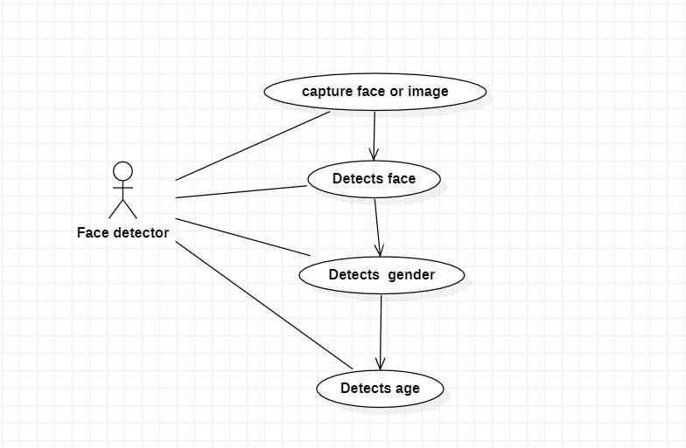

# UML DIAGRAMS

CLASS DIAGRAM

# C:\Users\K.POOJA\Downloads\Untitled.png

# UML DIAGRAMS

STATE DIAGRAM

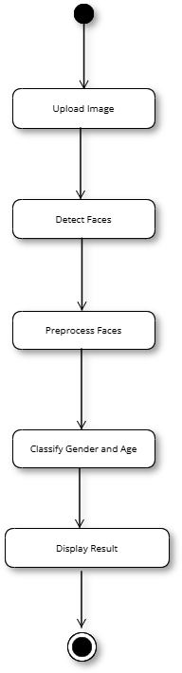

# CONCLUSION



This study demonstrated the effectiveness of Convolutional Neural Networks (CNNs) for age and gender detection from facial images. The proposed CNN architecture achieved high accuracy rates for both age and gender detection, outperforming traditional machine learning methods. The study also investigated the impact of different CNN architectures, data augmentation techniques, and robustness to variations in lighting, pose, and expression.

The results of this study have significant implications for various applications, including security, marketing, healthcare, and social media. The proposed system can be used to develop more accurate and reliable age and gender detection systems, which can be integrated into various real-world applications.

# REFERENCES



1. Abhijeet Awad, Sanket Sontakke, Nikita Narole, Vijay Nikalje, Prof. Arundaevi Khaple Real Time Age and Gender Recognition using CNN IRJMES International Journal of Research Publication and Reviews, Vol 4, no 5, pp 6515-6518, May 2023.
2. Marwa Ahmed and Serestina Viriri Gender Classification and Age Estimation Using Deep Learning Signal & Image Processing:An International Journal (SIPIJ) Vol.11, No.6, December 2023
3. Mehmet Karahan and colleagues from TOBB University of Economics and Technology, Ankara, Turkey Age and Gender Classification from Facial Features and Object Detection with Machine Learning J. Fuzzy. Ext. Appl. Vol. 3, No. 3 (2022) 219–230.
4. A Garain et al GRA Net: Deep Learning Model for Classification of Age and Gender From Facial Images IEEE Access ( Volume: 9) 85672 - 85689 03 June 2021.
5. Abdullah M. Abu Nada, Eman Alajrami, Ahmed A. Al-Saqqa, Samy S. Abu-Naser Age and Gender Prediction and Validation Through Single User Images Using CNN International Journal of Academic Engineering Research (IJAER) ISSN: 2643-9085 Vol. 4, Issue 8, August – 2020, Pages: 21-24.
6. D. Sabbagh, P. Ablin, G. Varoquaux, A. Gramfort, D. A. Engeman Age and Gender Prediction using Deep Convolutional Neural Networks 2019 International Conference on Innovative Computing (ICIC)
7. Ishita Verma, Urvi Marhatta, Sachin Sharma, Vijay Kumar Age and Gender Prediction Using Convolutional Neural Networks International Journal of Innovative Technology and Exploring Engineering (IJITEE) ISSN: 2278-3075, Volume-8 Issue-12S3, October 2019.
8. Y. Guo, Y. Liu, A. Oerlemans, S. Lao, S. Wu, and M. S. Lew Deep Learning for Gender Recognition and Age Estimation Neurocomputing ,Volume 187 , 26 April 2016, Pages 27-48.
9. Afshin Dehghan, Enrique G. Ortiz, Guang Shu, Syed Zain Masood Deep Age, Gender, and Emotion Recognition Using Convolutional Neural Networks Submitted on 14 Feb 2017 (v1), last revised 4 Mar 2017 (this version, v2)].



QUERIES?

THANK YOU